SIOPE Embryonal Tumour Group
3 April 2025 : 2 pm CET
Zoom call: https://newcastleuniversity.zoom.us/j/9630734103?omn=85111929087

Chairs. Simon Bailey and Olivier Ayrault
REST – Barry Pizer and Katja von Hoff

Agenda

13 00 – 14.10

- Introduction and Welcome - Simon Bailey and Olivier Ayrault - 5 Minutes (include final call for nominations for Chair and co-chair)

- Biology – 45 minutes – Olivier Ayrault

- REST Group - Barry Pizer, Katja von Hoff - 30 minutes
14.10– 16.00
- Trials Updates
  - Infant protocol update – Stefan Rutkowski and Christelle Dufour - 20 minutes
  - PNET 5 update - Stefan Rutkowski, François Doz and Martin Mynarek – 10minutes
  - HRMB update - Simon Bailey – 10 minutes
  - Trials biology update – Steve Clifford – 10 minutes
  - MB 6 concept – Martin Mynarek, Till Milde and François Doz - 15 minutes
  - STS update – Becky Hill - 10minutes

- Relapsed Medulloblastoma Group Feedback–– Rebecca Hill, Sabine Plasschaert, Gudrun Fleischhack, Christelle Dufour, Beata Timmerman- 15 minutes

- Survivorship update - Debbie Hicks - 15minutes

- ITCC –Steve Clifford - 15 minutes

- AOB

Minutes.

All were welcomed to the meeting.

- Biology.

    - Dr. Christelle Dufour (Gustave Roussy)

Clinico-proteomic integration in large-scale medulloblastoma cohort

Report on a cohort of medulloblastoma composed by 384 MB (France, Canada, Germany). This cohort (MB COMICS) is composed by primary medulloblastoma. The goal of the study was to generate and combine different omics information and clinical data. Regarding omics; methylome, transcriptome, proteome and phosphoproteome was generated as well as collection of clinical data for almost all patients. Data analysis using proteome revealed nine groups. In term of challenges, today there are established risk factors, and the goal was to use this dataset to decipher other factors that could be used to refine therapeutic stratification. To the end, MOFA (MultiOmic Factor Analysis) was employed, a PCA formalism extended to multiomic framework to integrate transcriptome/proteome with clinical data and generate factors. Several factors were extracted, one of them defined a group of high-risk Group 3, composed by MYC amp but also not amplified, associated with early diagnosis (< 3 years), LC/A histology, early time to relapse (< 1 year).

    - Dr. Stacey Richardson (Newcastle University)

Molecular pathology, treatment and prognosis of infant sonic hedgehog medulloblastoma: A global multi-cohort study.

Today for infant MB, therapy aims to delay/avoid radiotherapy, so far small non-randomized studies are available, and biomarkers do not inform therapies for infant medulloblastoma. Here, an international infant medulloblastoma cohort (0-4.99 years), n=646 MB (Canada, France, Italy, Japan, Netherland, Spain, UK, USA, Germany) was generated. The goal was to capture real-world experience of infant MB, define therapies and biomarkers with a focus on SHH MB. SHH-1 and SHH-2 subgroups predominate in infant MB. SHH-1/2 do not share poor prognosis of TP53 mutated SHH-3. In this group (SHH1/2) chemotherapy type and intensity are key prognostic factors. High dose and intraventricular MTX (IVT-MTX) are equivalent. Histology is not prognostic using contemporary therapies, however metastatic stage is prognostic in IVT-MTX. Cross-validation and validation with non-randomized trials were performed. This study aims to define evidence-based to inform future clinical and research studies (stratification groups, survivorship outcomes, biological studies, COGNITO).

- REST group. Katja von Hoff and Barry Pizer

Topics
1) ESCP Guideline on Pineal Tumours (5 min)
2) SIOP-E CNS REST Registry (5 min)
3) Tumour Board (5 min)
4) ETMR Strategy Meeting (5 min)
5) Discussion (10 min)

The SIOP-E REST group was established in 2022 and has since produced relevant output, of which is one is the ESCP on REST Tumours, several publications (some in submission/in press), a Grant from the UK Brain Tumour Charity, and the ESCP on pineal Tumours.

Re 1): ESCP Guideline on Pineal Tumours. This is not yet published on the SIOP E website, but the publication is available under: https://www.ejcped.com/article/S2772-610X(25)00004-2/fulltext

Re 2) There was a first Steering Committee Meeting to the SIOP-E CNS-REST Registry.
At the current we wait for the final vote of the Danish National Ethics Committee.
We will inform the national coordinators once available with all relevant documents for support of the national submissions.
Discussion: There is currently no central funding available to support the national opening of the Registry or for case-based compensation of registration. Central funding was requested at Fight Kids Cancer and other funders, but without support yet. We therefor ask the national groups to seek support of their national funding agencies. Important, there are no central costs for participating in the SIOP-E CNS-REST Registry, and neither for case consultations in the ERN-REST Tumour Board (see below). Due to the rarity of the diseases and due to the lack of standards of care, we expect the work associated with documentation of the patients not relevantly surpassing the work associated with individual research and local/national case discussions. But we expect the international collaboration a relevant resource for all physicians responsible for such patients.

Re 3) The ERN-REST Tumour Board is about to start. A core group of discipline experts have been agreed to support the board, which will be held on the ERN-PaedCan platform CMPS2.0.
Participation in the Tumour Board will require the set-up of an EU-login. (A test version of the platform is available here: https://cpms2-acceptance.ern-net.eu. At this page you can also register. Information /support is given at the bottom at the page)
All relevant information for request and preparation of patient discussions will be soon included on the Paedcan-e-health webpage.
For now please send inquiries for patient discussion via mail to the coordinators (katvon@rm.dk, johannes.gojo@meduniwien.ac.at, or Barry.Pizer@alderhey.nhs.uk)
Note that it is up to the respective institution, where the patient is treated, if a consent for uploading data for the Tumour Board discussion is necessary. If necessary, you will find consents in all EU languages at the website. Consents will need insertion of information on data protection officer.

Re 4) Brief information on the ETMR strategy meeting is given. Central outcome of the meeting is an agreement to work towards harmonization and the perspective of a global trial to actually answer questions given the numbers involved. Importantly: Further detailed information and discussion of the European approach will follow at the upcoming REST group virtual meeting.
Discussion: There was a question, if ETMR and pineoblastoma will be included in Triumph. Note that we will discuss this in the upcoming REST group meeting.

5) Discussion: There are further relevant topics as liquid biopsy, output/data from joint analyses, collaboration with other groups as the Childrens National Registry for rare tumours and many more. We will discuss these topics at the upcoming REST group meeting.
Thanks to all SIOP-E REST group members for the collaboration and support.

4. Trials Update.
  - Infant protocol update – Stefan Rutkowski and Christelle Dufour
Stefan Rutkowski presented update on Cognito for SHH infant MB. Slide below is summary of the trial. 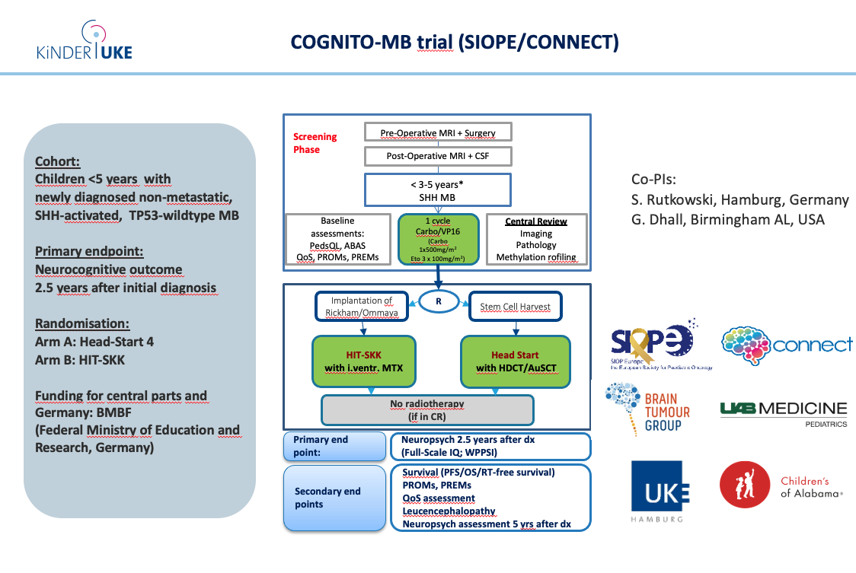
Issue with German regulatory bodies re stem cells so resubmitted through Denmark. Timeline below.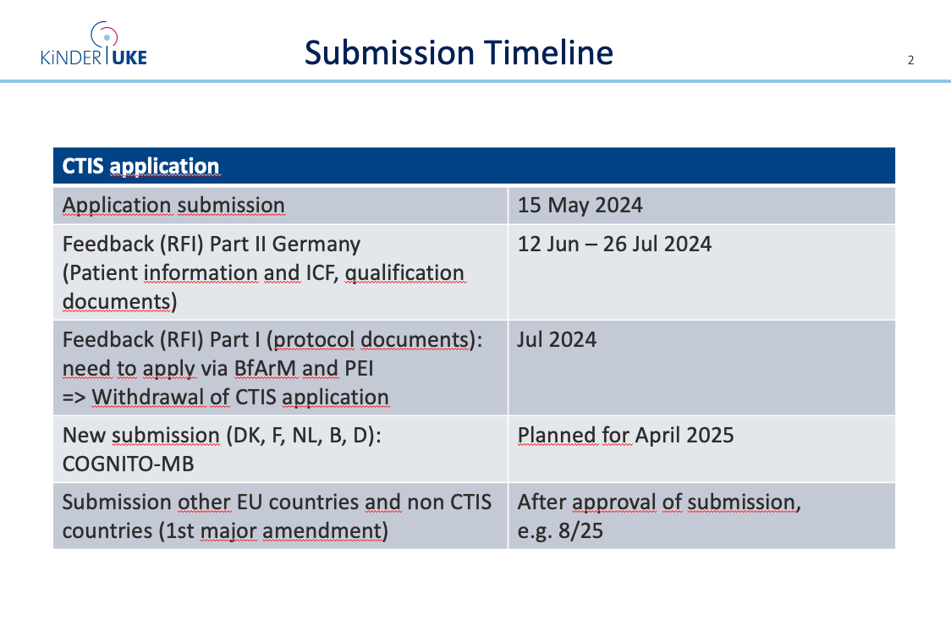
More details, on Neurocognitive assessment given.
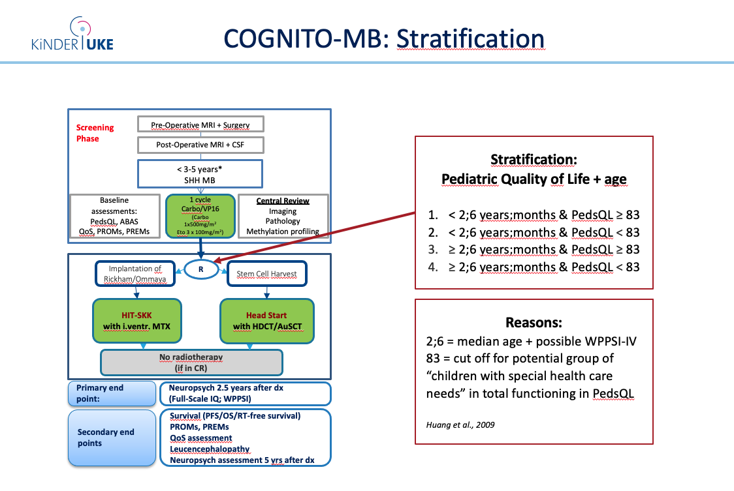
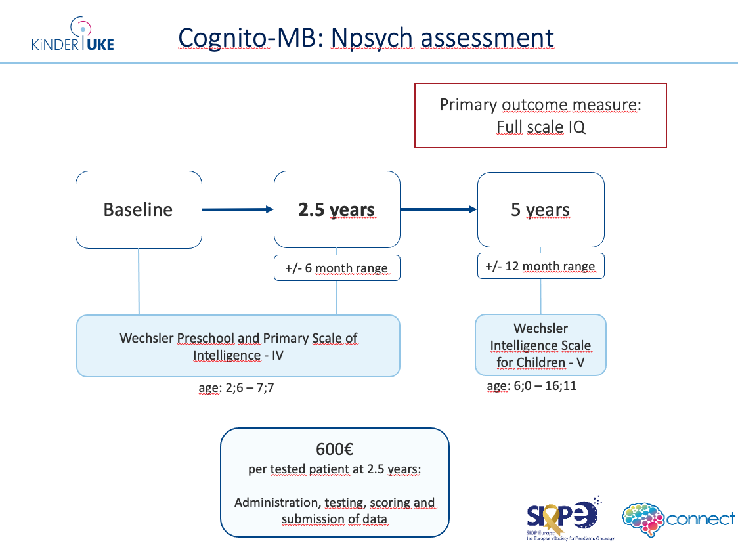
TriuMPh. Christelle Dufour presented Triumph for high risk medulloblastoma cohort. Poor outcome for this cohort although high dose therapy appears to improve outcome. Molecular data from metanalysis presented by Steve Clifford. Subgroup IV do very well with High dose therapy. MYC patients do very badly. Subgroup II/III without myc have 49% PFS. 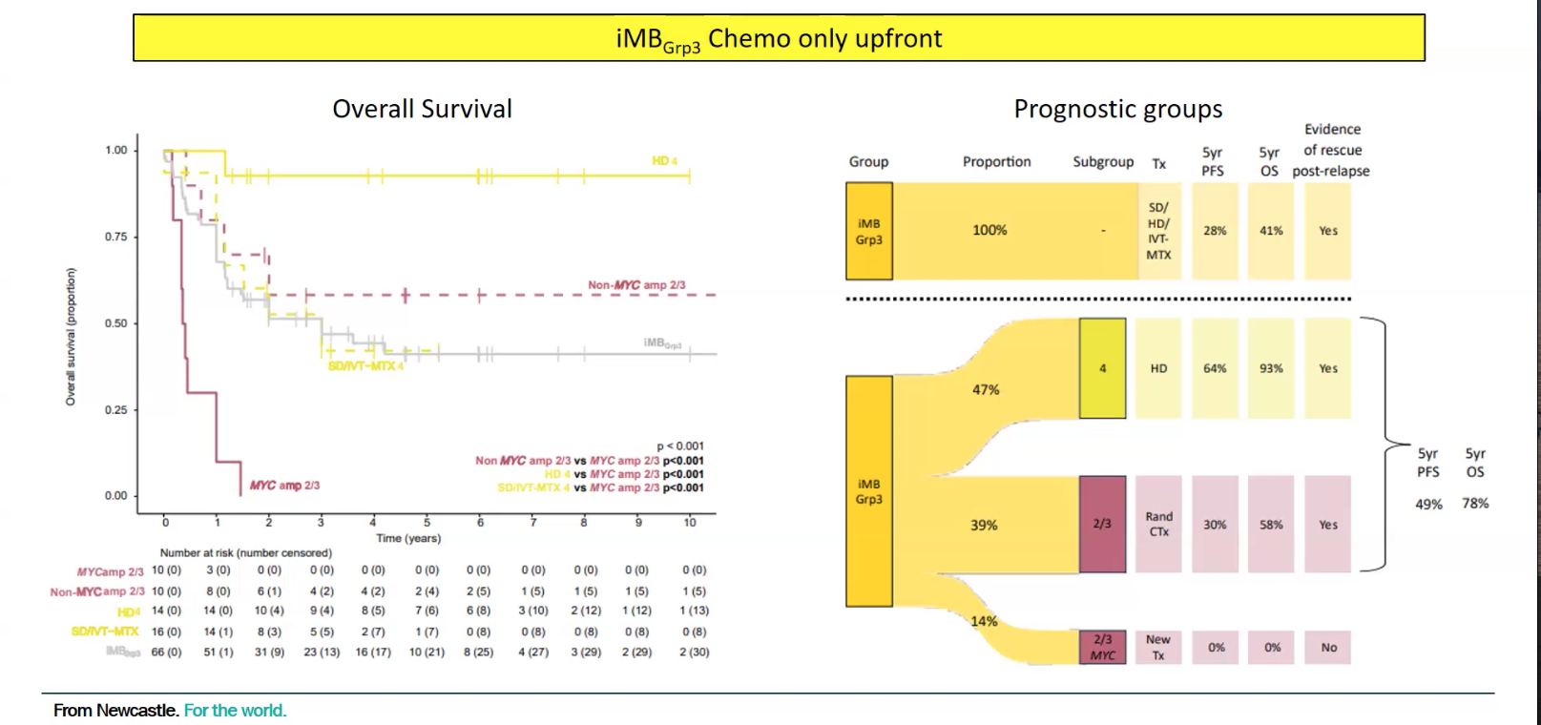

Proposal presented below. Data presented by Martin Mynarek for metastatic SHH. Randomisation would be balanced for age, M stage Histology, MYC status and subgroup.
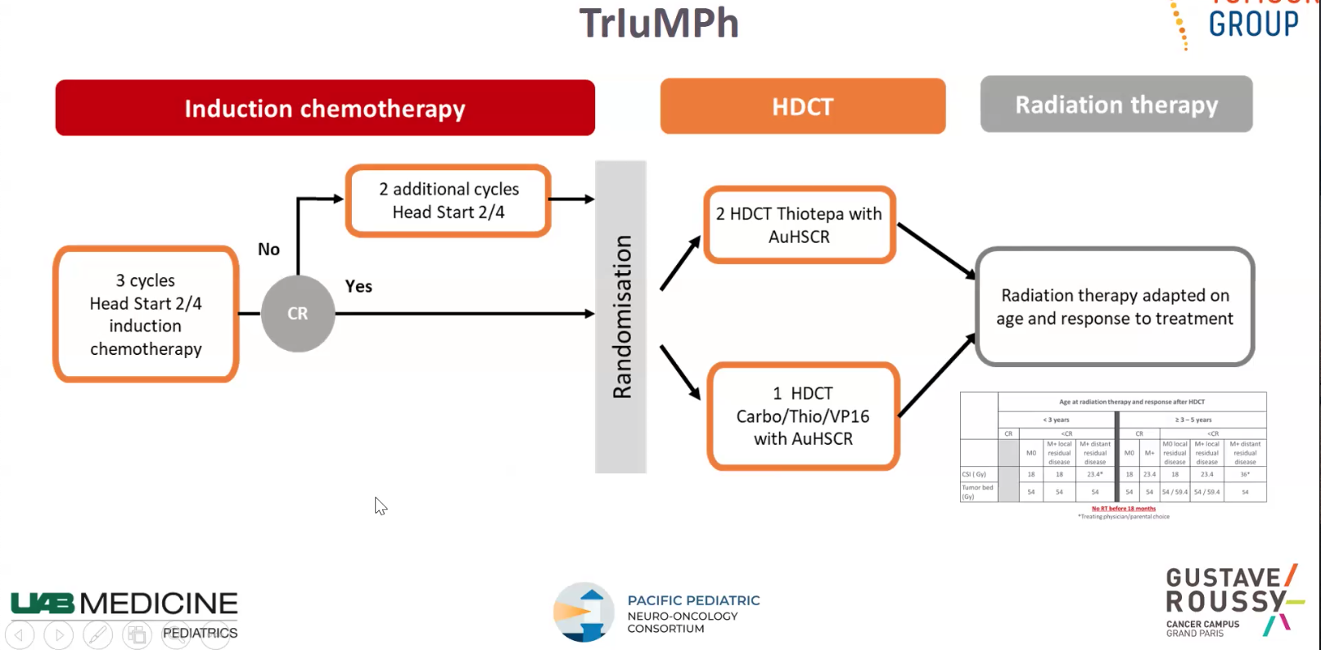

  - PNET 5 update - Stefan Rutkowski, François Doz and Martin Mynarek
Stefan Rutkowski presented updated on the closed PNET5. Recruitment completed 3 years ago and timeline below. A plea was made to send in all outstanding data. QOS assessment data was presented, 5 year follow up is here the returns are not as good.
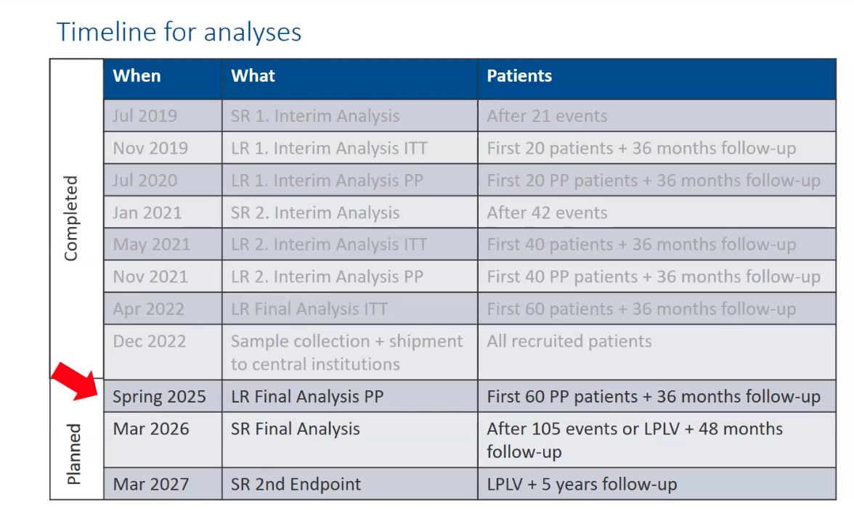

  - HRMB update - Simon Bailey presented an update, 158 patients screened (many are standard risk patients but with no Standard risk trial opened screening in case in case of biological high risk is done in some countries). 81 patients in R1 and 40 in R2. Amendment been submitted with updated statistics with reduced numbers – 650 but with useful information form 400 upwards. CTIS also submitted.

  - Trials biology update
Steve Clifford presented summery of biological studies . PNET 5 total number of cases 394, 386 methylation array data, 381 with mutation data, RNA seq 350 will be possible (160 of these working , proteo omics 341 tumour and 239 for blood, day 14 CSF on day 14. Slides being digitised. Low risk arm, monsomy 6 in 88%, 15% TP53 mutated. Infant data from metanalysis reiterated. CSF mandatory in updated HRMB protocol amendment. High risk meta analysis being undertaken. MB6 Biological studies and diagnostics in planning and Biology Manual being updated to take into account new trials.
New developments include urine and end of therapy and CSF sampling in Cognito, end of radiation CSF in HRMB and real time idats and digital path submission.
  - MB 6 concept – Martin Mynarek, Till Milde and François Doz
The updated trial outline was presented by Martin Mynarek but has no major changes. The trail has been submitted for German funding. The projected timeline was also presented.
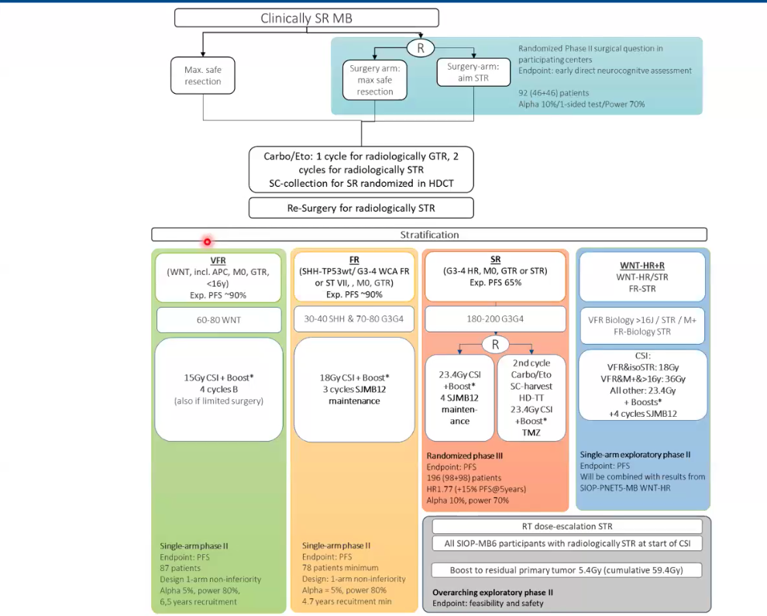
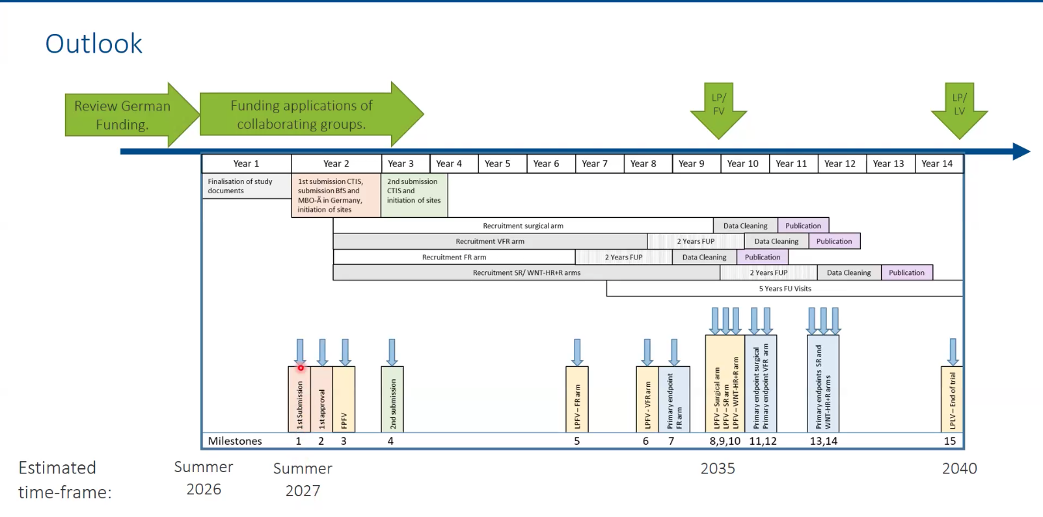
  - STS update – Becky Hill - 10minutes
Becky Hill presented updates of the STS group. Work is ongoing with preclinical models. A proposed scheme was presented with regards to sue of STS with alkylating agents (will probably use 6 hour gap after STS). STS should be given 15 minutes. Guidelines in UK with NICE allowing STS with non metastatic disease are being produced.

- Relapsed Medulloblastoma Group Feedback

Becky Hill presented work form this group. Beat Timmerman is leading on a retrospective reirradiation study. Study is open and could people please contact Beata if you are interested in contributing. Consensus guidelines are being drawn up following the Cancers paper.

6. Survivorship update

Debbie Hicks spoke of SMILE group initiatives, one is looking at survivorship outcomes using PNET 3 and 4 trial cohorts (QOS and neurocognitive) along with molecular tumour characteristics. SNPs were also used to look for correlations. The work is beginning to mature. Will get hypothesis to look at PNET 5 cohort. Another initiative is to look at maximising neuropsychologic data collection in PNET 5 and HRMB. Pharmacological and non pharmacological interventions are also being looked at.

7. ITCC
Steve Clifford discussed ITCC initiatives of MB working group. Aim is to open early phase trials in MB. Very few targets and nothing for VHR tumours. Group meet monthly and represent a number of disciplines. MB and Life ARC workshops have been held. Scientific evidence, target tractability, target prioritisation and best drug modalities and combinations are looked at. Twelve workshops will be held. Some conclusions were that SRC degrader is a potential target and other priorities include MYC and MYCN. ITCC Brain TAP platform described.

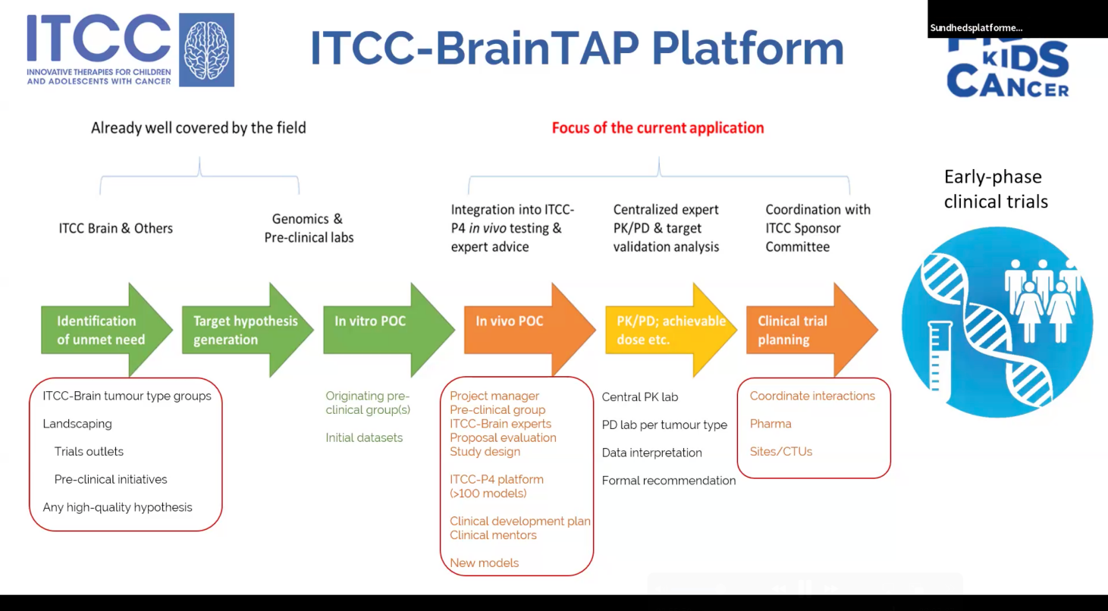
A trial development workshop was held at the ITCC meeting in Newcastle with a number of suggestions including closer collaboration with US groups, development of the early phase window built into HRMB especially for the VHR groups and to use the BRAINTAP pathway for introduction of drugs into clinical practice.

The group will meet again in Porto in September.

